Exercise 3: Stored Procedures
Step 1:
Create sample tables :
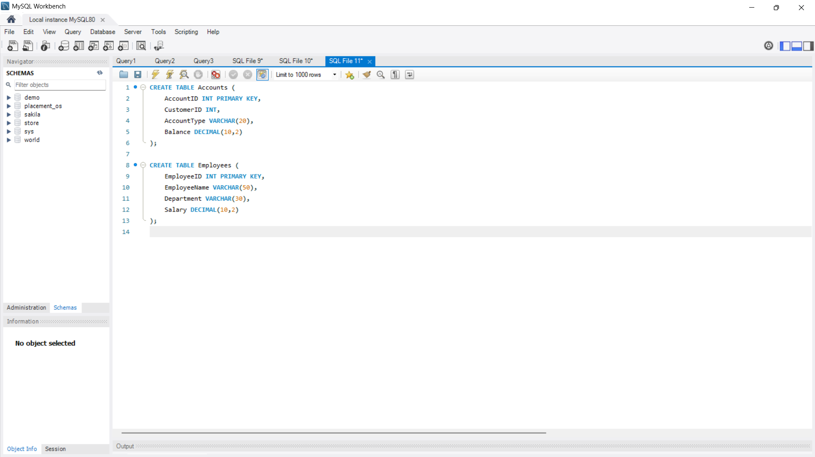
Step 2:

Insert sample data:
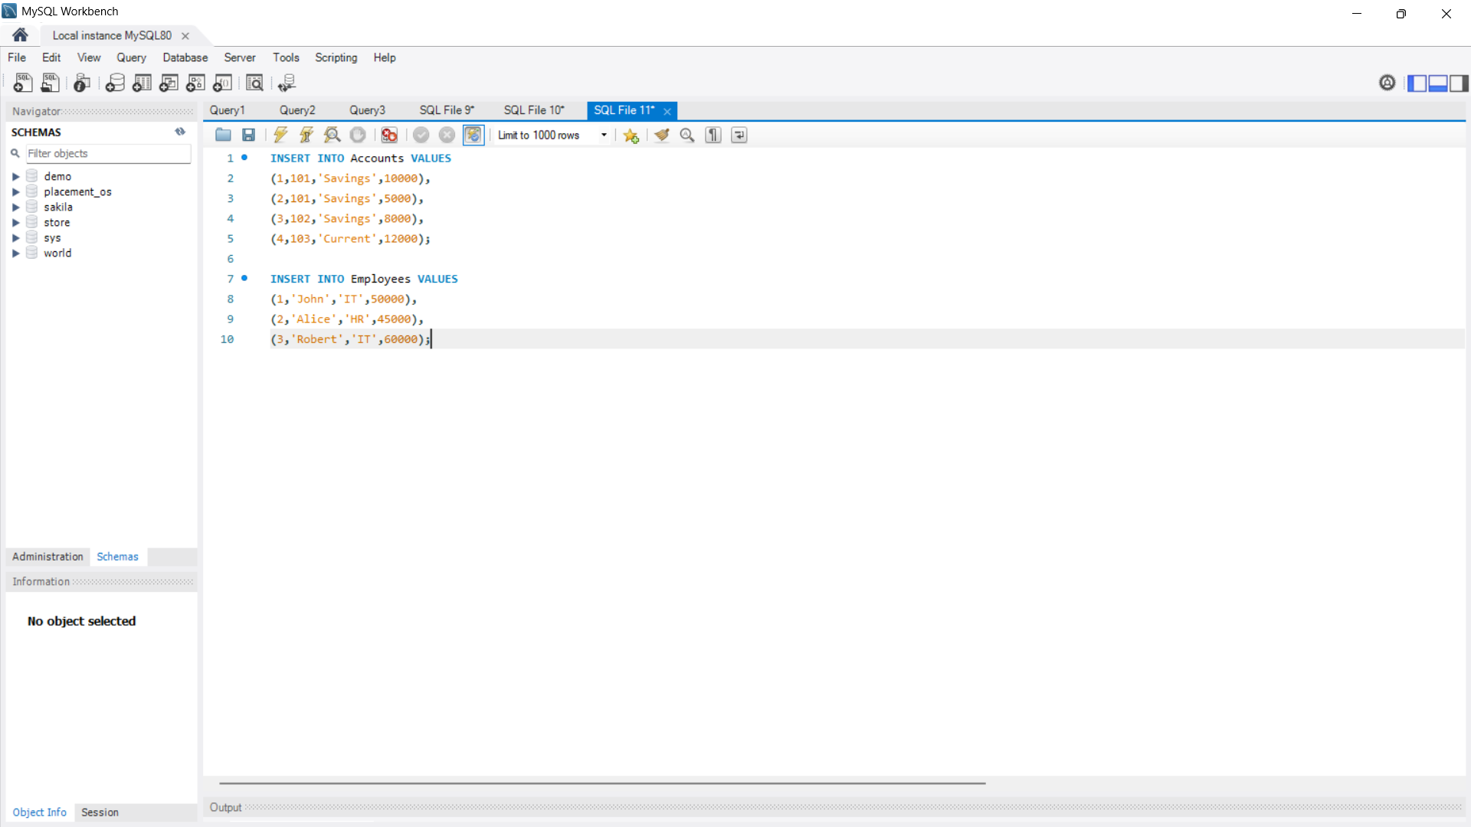

Scenario 1: The bank needs to process monthly interest for all savings accounts.
Question:
Write a stored procedure ProcessMonthlyInterest that calculates and updates the balance of all savings accounts by applying an interest rate of 1% to the current balance.
Script / Query:

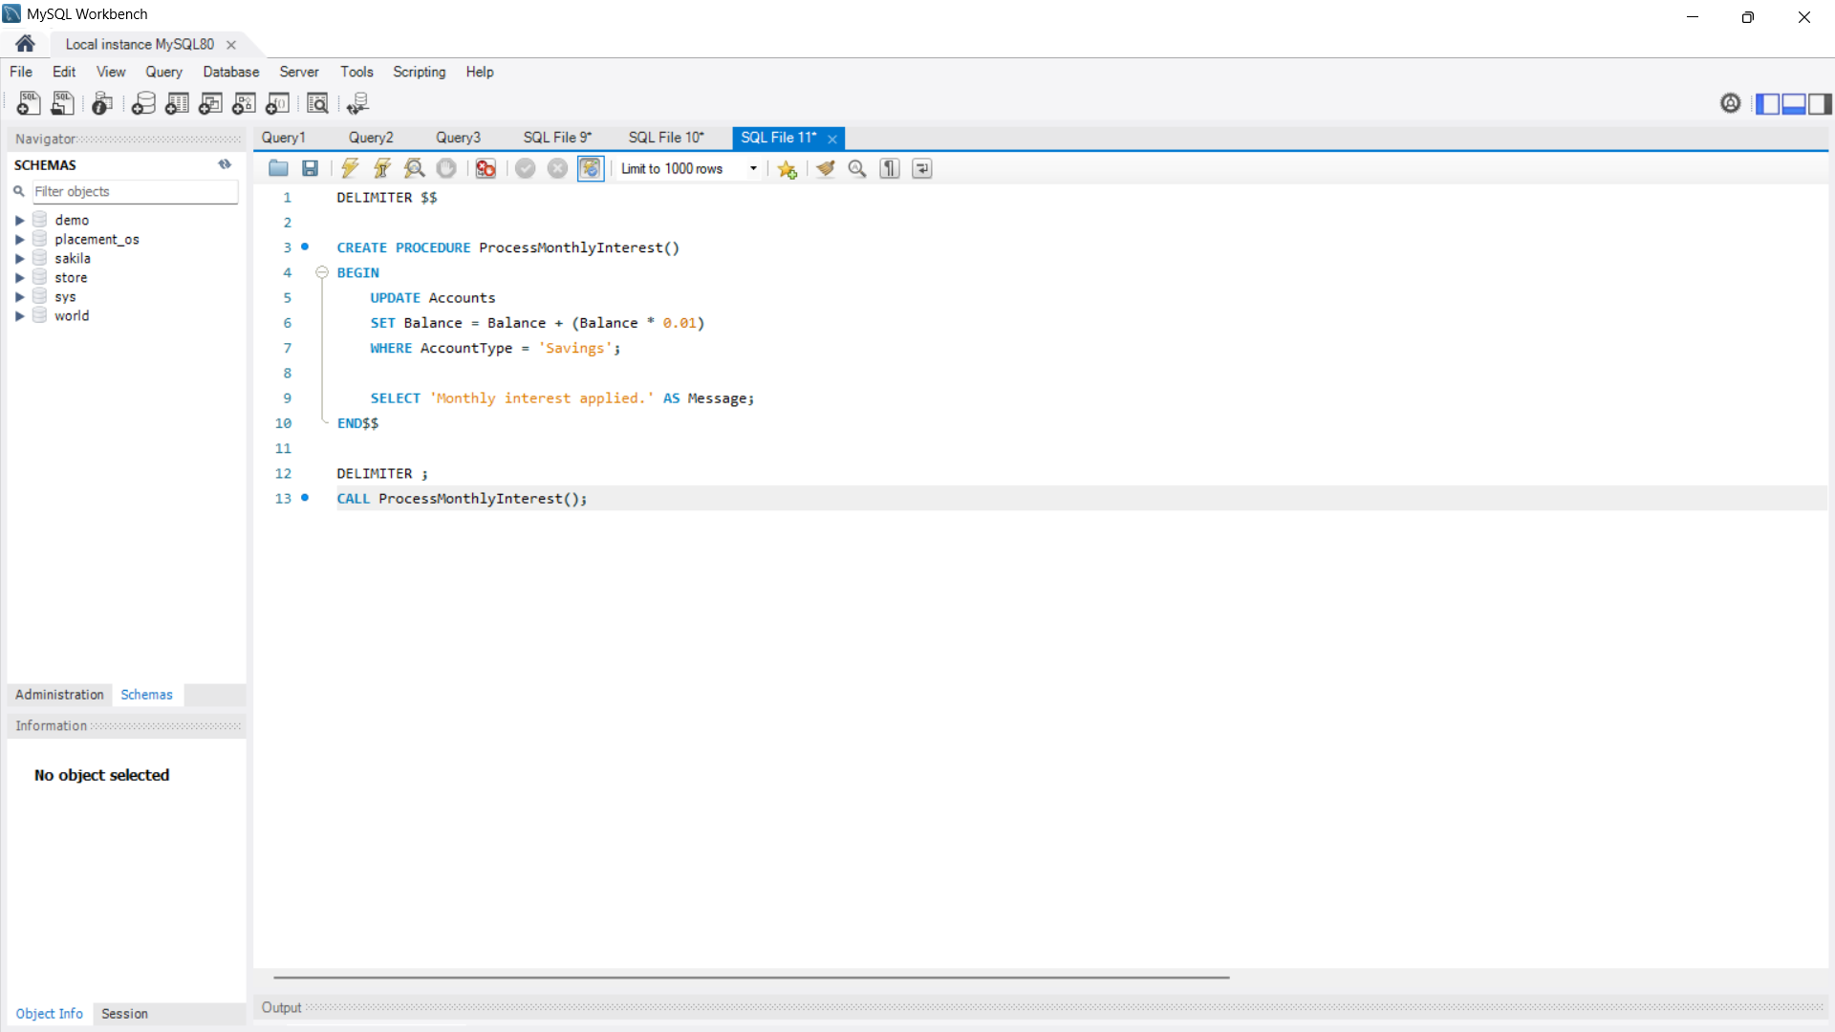
Output:
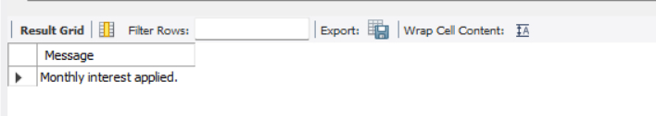

Explanation:
Updates the balance of all savings accounts by adding 1% monthly interest.

Scenario 2: The bank wants to implement a bonus scheme for employees based on their performance.
Question:
Write a stored procedure UpdateEmployeeBonus that updates the salary of employees in a given department by adding a bonus percentage passed as a parameter.
Script / Query:
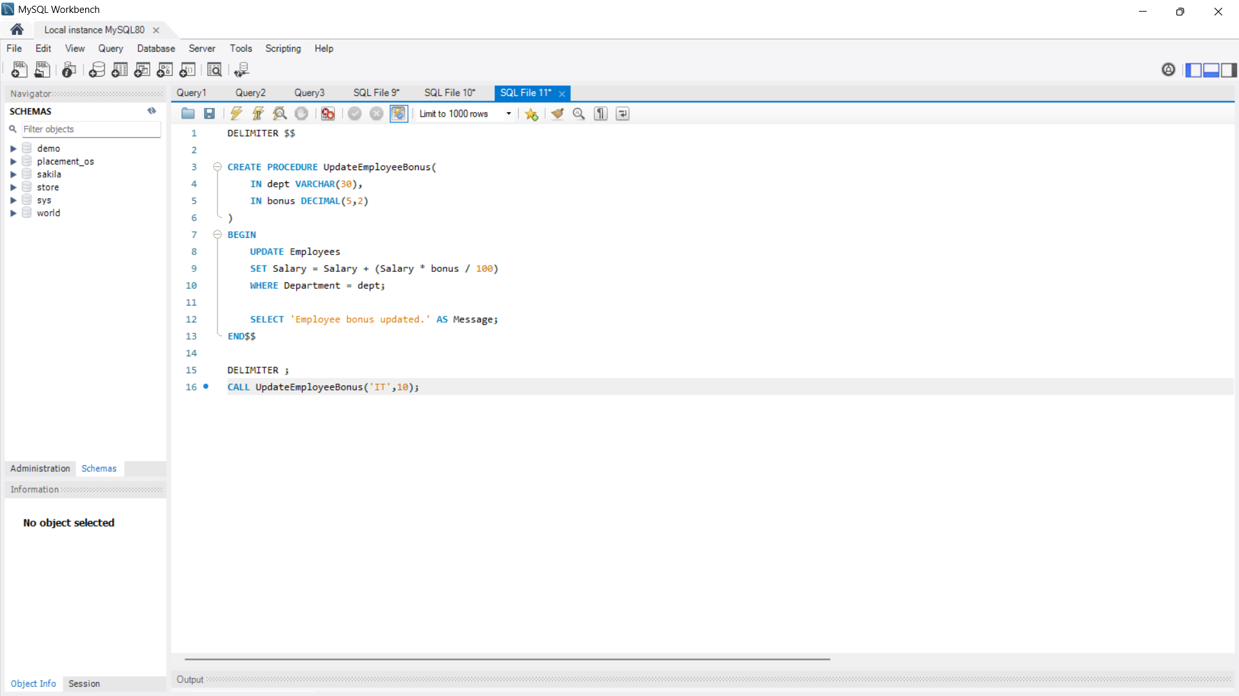
Output:
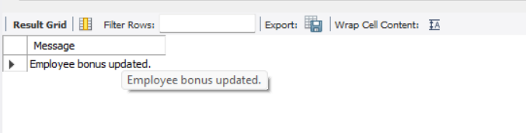

Explanation:
Updates the salary of employees in the given department by adding the specified bonus percentage.

Scenario 3: Customers should be able to transfer funds between their accounts.
Question:
Write a stored procedure TransferFunds that transfers a specified amount from one account to another, checking that the source account has sufficient balance before making the transfer.
Script / Query:
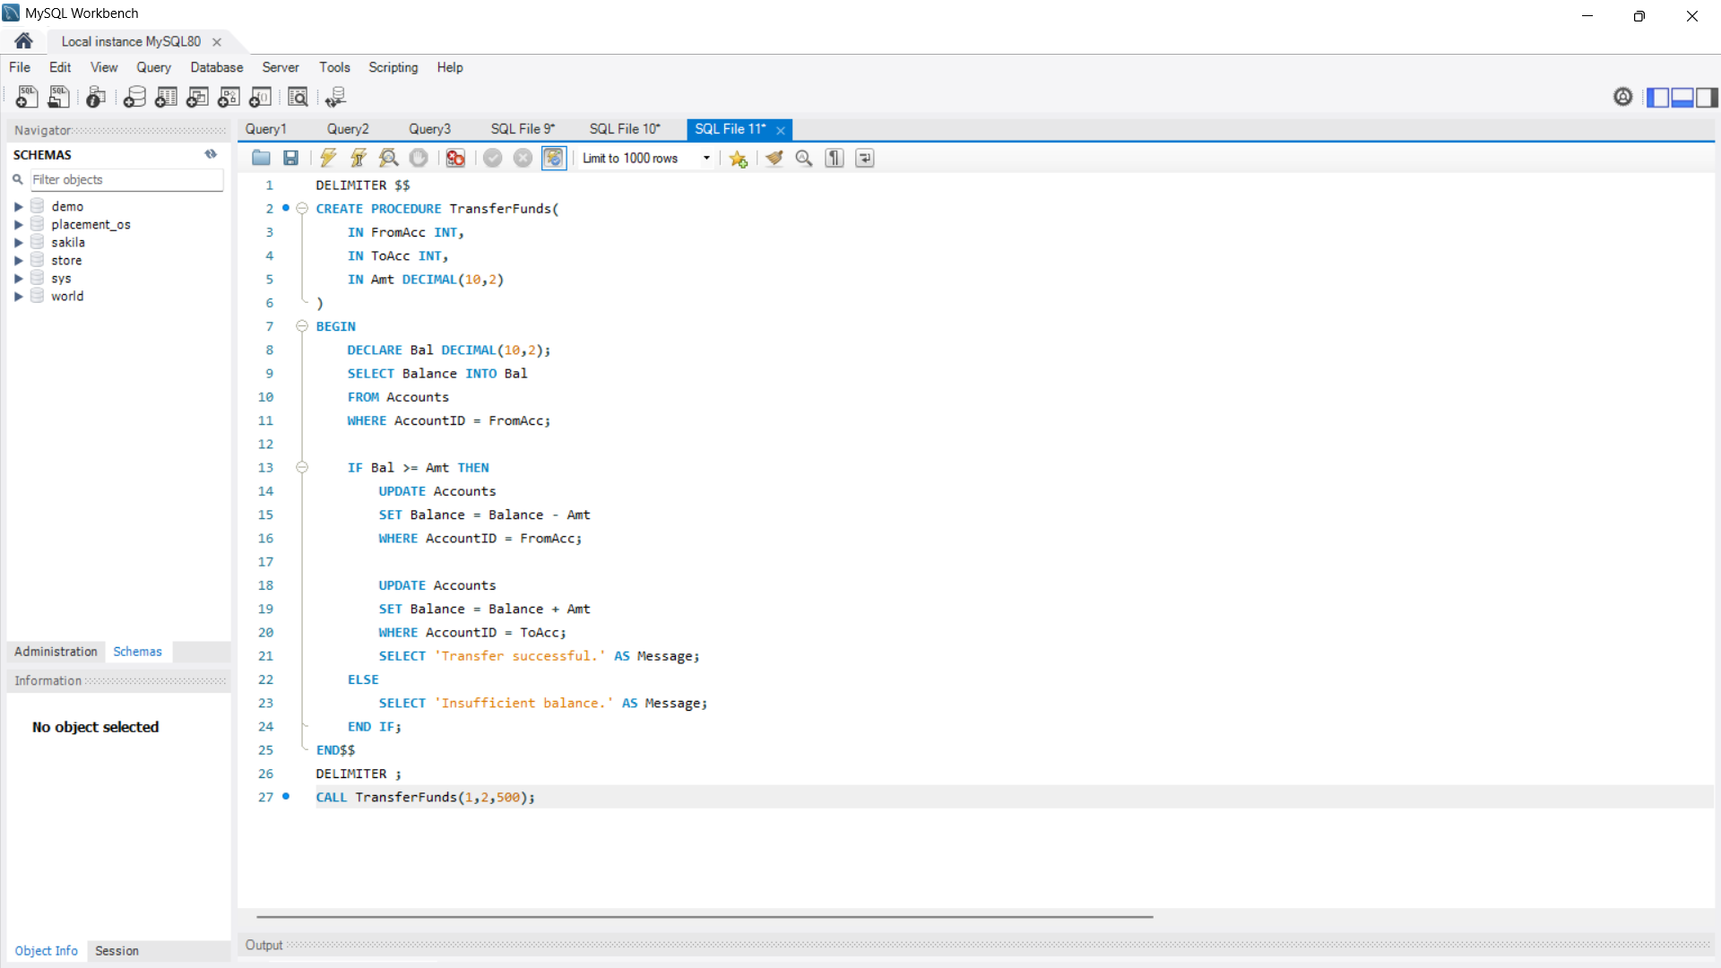
Output:
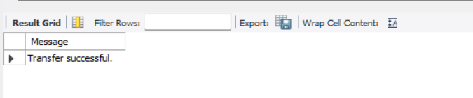

Explanation:
Checks whether the source account has sufficient balance. If sufficient, the amount is transferred; otherwise, an "Insufficient balance" message is displayed.

